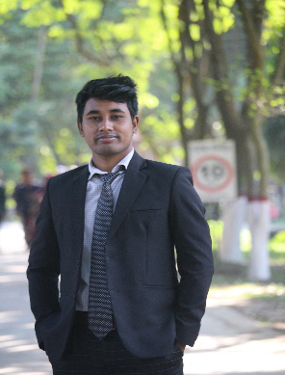
RESUM
OF
JIBAN CHANDRA RAY
Mobile: +8801615752645
Email: jiban.brur.2000@gmail.com
Github: jiban 123ray
Linkedin: jiban-chandra-ray-b89822345

Career Objective :
I will work in various locations in Bangladesh or in the creative department of the company and grow rapidly with increasing responsibilities. I have the ability to think creatively and simplify difficult tasks. I have the ability to communicate well with people. I am able to work with patience and communication skills.
Educational Qualification :
- Bachelor of BSS
Name of Institution : Begum Rokeya University, Rangpur
Department : Mass Communication and Journalism
Result : CGPA 3.21 Out of 4
Passing year : 2024
- Higher Secondary Certificate
Name of Institution : Nageshwari Govt. College, Kurigram.
Board : Dinajpur.
Subject : Science.
Result : GPA 3.75 Out of 5
Passing year : 2018
- Secondary School Certificate
Name of Institution : Hasanabad Adarsha Janata Bidyabitan High School, Kurigram.
Board : Dinajpur.
Subject : Science.
Result : GPA 5.00 Out of 5
Passing year : 2016
Language Proficiency :
- English : Fluent.
- Bangla : Fluent.
Personal Strengths :
- Good analytical ability
- Can use initiative constructively in order to overcome in barriers.
- To peruse a career that offer opportunities for self-developments.

Computer Skills :
- Computer Training Course for 6 Month.
- MS Word, MS Excel, MS Power Point, MS Access
- Internet Browsing.
- Data Entry Operator.
Personal Information :
Name : Jiban Chandra Ray
Father’s Name : Jogendra Nath Ray
Mother’s Name : Chantra Ray
Date of Birth : 25/10/2000
Marital Status : Unmarried
Religion : Hinduism
Nationality : Bangladeshi
National ID No. : 5564373743
Gender : Male
Height : 5’6”
Blood Group : AB+ (Positive)
Phone : 01615752645
Present Address :
Village : Chack Bazar Post office : Cadet College
Upozila : Tajhat District : Rangpur
Permanent Address :
Village : Khattri Para Post office : Hasanabad
Upozila : Nageshwari District : Kurigram
Declaration :
I do hereby declare that all this statement made above are true, correct and complete to the best of my Knowlegdge.
Reference :
Anil Chandra Barman (Retirement Assistant Techer)
Newashi High School, Kurigram
Phone: 01725998056

03/05/2025
Signature

